Syeda Reeha Quasar

14114802719

4C7

Aim

Write a program to demonstrate the use of special functions, constructor and destructor in the class template. The program is used to find the bigger of two entered numbers.

Experiment - 15

Object Oriented Programming Lab

# **EXPERIMENT – 15**

## **Aim:**

Write a program to demonstrate the use of special functions, constructor and destructor in the class template. The program is used to find the bigger of two entered numbers.

## **Source Code:**

#include<iostream>

using namespace std;

class biggest

{

private:

    int a, b;

public:

    void display() //constructor function

    {

        if (a > b)

            cout << "Biggest no.:" << a << endl;

        else

            cout << "Biggest no.:" << b << endl;

    }

    ~biggest() //destructor function

    {

        cout << "Objects are destroyed" << endl;

    }

    biggest(int a, int b) //Bigger of two numbers

    {

       this->a = a;

       this->b = b;

    }

};

int main()

{

    int x, y;

    cout << "Enter numbers you want to compare:" << endl;

    cin >> x >> y;

    biggest bigger (x, y);

    bigger.display();

    return 0;

}

## **Output:**

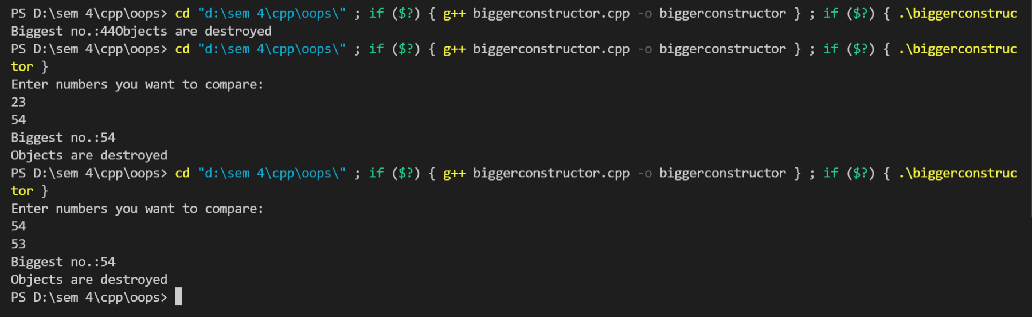

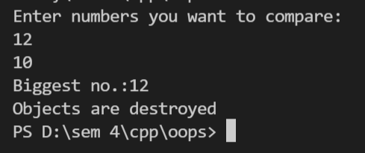

# **Viva Questions**

#### Q1) What is a class constructor?

Ans.

A class constructor is a special member function of a class that is executed whenever we create new objects of that class.

A constructor will have exact same name as the class and it does not have any return type at all, not even void. Constructors can be very useful for setting initial values for certain member variables.

#### Q2) Are Constructors and destructors can declare as const?

Ans.

Constructors and destructors can’t be declared as const or volatile. They can, however, be invoked on const or volatile objects.

#### Q3) What is a Destructor?

Ans.

Destructor is a member function which destructs or deletes an object.